*s*

*Mini Project Report On*

# “YOUTUBE VIDEO SUMMARIZATION”

*Submitted By*

**Ms. Rutuja Savata Raut(Roll No - 49)**

**Ms. Nikita Vivek Pawar(Roll No - 50)**

**Ms. Sakshi Vikas Pawar (Roll No - 51)**

**Ms. Gauri Shashikant Pawar (Roll No - 52)**

*Under the Guidance of*

***Prof. S.G.LINGE***

*For The Award of the Degree of*

### Third Year Bachelor of Technology

### D:\SKN\Distributed System\2023-24\images.png

DEPARMENT OF COMPUTER SCIENCE AND ENGINEERING

### S K N SINHGAD COLLEGE OF ENGINEERING

**Korti, Pandharpur .**

**Punyashlok Ahilyadevi Holkar Solapur University Solapur.**

**2023-2024**

### DEPARTMENT OF COMPUTER SCIENCE AND ENGINEERING

**SKN SINHGAD COLLEGE OF ENGINEERING**

### Korti, Pandharpur

### D:\SKN\Distributed System\2023-24\images.png

### --(Accredited by NAAC ‘A+’ Grade)--

CERTIFICATE

*This is to certify that, the mini project report entitled*

***“YOUTUBE VIDEO SUMMARIZATION”***

*Submitted by*

**Ms. Rutuja Savata Raut (Roll No - 49)**

**Ms. Nikita Vivek Pawar (Roll No - 50)**

**Ms. Sakshi Vikas Pawar (Roll No - 51)**

**Ms. Gauri Shashikant Pawar (Roll No - 52)**

*In the fulfilment for the award of the Degree of*

***Third Year Bachelor of Technology***

*This Design work is a record of student’s own work carried out by under my supervision and guidance during the academic year*

***2023-24***

**Project Guide Mini-Project Co-Ordinator**

**(Prof. S.G.Linge) (Prof. M. S. Koli)**

**Head of Department External Examiner**

**(Dr. S. V. Pingale)**

# Acknowledgment

We have great pleasure in presenting this project report on **“YOUTUBE VIDEO SUMMARIZATION”** we take this opportunity to express sincere appreciation and deep sense of gratitude to our project guide **Prof. S.G. Linge for** his whole hearted cooperation, valuable guidance and perpetual encouragement, which had a great influence in bringing this project to success. We remain ever indebted to him for the keen interest shown and moral support offered all through pursuance of this work.

We also express our sincere thanks to, **Dr. S. V. Pingale** Head, Dept. of Computer Science and Engineering for extending all the facilities required for this project work. We express our sincere thanks to principal **Dr. K. J. Karande** for extending all facilities required for this project work.

We express our heartfelt thanks to all our colleague friends for their constant encouragement and full cooperation whenever required.

**Ms. Rutuja Savata Raut (Roll No - 49)**

**Ms. Nikita Vivek Pawar (Roll No - 50)**

**Ms. Sakshi Vikas Pawar (Roll No - 51)**

**Ms. Gauri Shashikant Pawar (Roll No - 52)**

**DECLARATION**

We the undersigned hereby declare that the declaration entitled **“YOUTUBE VIDEO SUMMARIZATION”** submitted by us to SKN Sinhgad College of Engineering, Pandharpur for the award of the degree of Bachelor of Engineering in Computer Science and Engineering, under the guidance of **Prof.S.G. Linge** is our original work. We further declare that to the best of our knowledge and belief, this work has not been submitted to this or any other university.

**Ms. Rutuja Savata Raut (Roll No - 49)**

**Ms. Nikita Vivek Pawar (Roll No - 50)**

**Ms. Sakshi Vikas Pawar (Roll No - 51)**

**Ms. Gauri Shashikant Pawar (Roll No - 52)**

**ABSTRACT**

The paper goal is to design a user interface where the user can get the summary of the requested YouTube video using Natural Language Processing (NLP) and Machine Learning. Enormous number of videos are uploaded to YouTube daily. It has become difficult to find the relevant content that we are looking for, sometimes it may take longer than expected, and our efforts be- come futile if we are unable to extract meaningful information from it.

This is where our project becomes handy. It will summarize the video and display the summary of it. Abstractive summarization model extracts YouTube video transcripts and generates a summarized version. It saves our time by shortening the content to read while maintaining the important content of the actual document. The implementation process is still ongoing. However, the entire structure and studies are presented.

**Keywords** : Natural Language Processing · Machine Learning · Abstractive summarization

**CONTENTS**

1. INTRODUCTION 01
   1. Project introduction 01
   2. Why we choose this project 01
   3. Benefits of project 02
   4. Application 02
   5. Scope of the project 02
2. Literature review 03
3. Proposed work 04
   1. Problem statement. 04
   2. Objective 04
4. Methodology 05
5. Project design. 07
   1. Data flow diagram 07
      1. Level 0 DFD 07
      2. Level 1 DFD. 08
6. System requirements. 09
   1. Software requirements 09
   2. Hardware requirements 09
7. Implementation. 10
   * 1. Admin / User Interface Design
     2. INTERFACE DESIGN: (Important Screenshots of Front End) ……………...11

i) Home page. 12

* + - 1. About us. 12
      2. Result page. 12

1. RESULT 13
2. CONCLUSION. 14
3. REFERENCES. 15

**List of Figures**

|  |  |  |
| --- | --- | --- |
| 4.1 | FLOWCHART | 05 |
| 5.1 | LEVEL 0 DFD | 07 |
| 5.2 | LEVEL 1 DFD | 08 |
| 7.1 | HOME PAGE | 11 |
| 7.2 | ABOUT US | 12 |
| 7.3 | RESULT | 12 |
| 7.4 | English Transcript | 14 |
| 7.5 | Hindi Transcript | 14 |

**1.INTRODUCTION OF PROJECT**

### PROJECT INTRODUCTION:

Transcribing YouTube videos using NLP ASR algorithms is a powerful tool for extracting valuable insights from audio content. This process involves converting audio into text, summarizing the transcript, and analyzing the output for meaningful information. In this guide, we will walk you through the steps to transcribe YouTube videos using NLP algorithms, highlighting the key techniques and tools involved.

The primary objective of this project is to develop and implement a system for summarizing YouTube videos effectively. By distilling the key information and insights from lengthy videos into concise summaries, our aim is to enhance user experience, save time, and facilitate better information retrieval.

This project not only addresses the practical need for video summarization but also delves into the realm of artificial intelligence and natural language processing, leveraging advanced techniques to extract meaning from multimedia content.

### WHY WE CHOOSE THIS PROJECT:

The decision to embark on a YouTube video summarization project stems from several key factors. Firstly, there is a clear market demand for tools that can condense lengthy videos into concise summaries, particularly on platforms as vast as YouTube. Such a tool would cater to users who are time-constrained but still seek to glean valuable insights from videos.

Moreover, there is immense educational value in summarizing videos, as it can make complex concepts more accessible and facilitate quicker learning. By undertaking this project, there is an opportunity to innovate in the field of natural language processing and machine learning, demonstrating the ability to leverage technology for enhancing user experiences. Additionally, working on this project offers a chance to develop highly sought-after skills while aligning with personal interests in video content. Overall, the project's practical applications extend beyond YouTube, making it a relevant and potentially impactful endeavor.

### BENEFITS OF PROJECT:

This is a very simple design and implement. It has got following features:

* + - Time Saving
    - Enhanced Accessibility
    - Learning Aid
    - Content Curation
    - Innovation
    - Skill Development
    - Market Demand
    - Practical Applications

### APPLICATIOS:

A YouTube video summarization project can be applied in education for quick concept understanding, content consumption for efficient video browsing, research for rapid information review, content creation for trend analysis, marketing for promotional content, accessibility for people with disabilities, corporate training for concise learning materials, and news media for creating news clips.

### SCOPE OF THE PROJECT:

* + - Algorithm Development: Develop algorithms to extract key information from videos.
    - User Interface: Create a user-friendly interface for accessing summarized content.
    - Compatibility: Ensure compatibility with various video formats.
    - Continuous Improvement: Implement a system for improving summarization based on user feedback.
    - Integration: Potentially integrate with other platforms or services for broader reach.

## 2.LITERATURE REVIEW

|  |  |  |  |  |  |
| --- | --- | --- | --- | --- | --- |
| **Author** | **Year** | **Objective** | **Pros** | **Cons** | **Platform**  **Used** |
| Smith et al. | 2019 | Investigate deep learning techniques for video summarization. | * Deep learning enables effective feature extraction from videos. | * Requires large amounts of annotated data for training | YouTube, Vimeo |
| Wang and Zhang | 2021 | Propose a graph-based approach for YouTube video summarization | * Able to capture relationships between video segments | * May be computationally expensive for large videos | Graph-based techniques |
| Johnson & Lee | 2020 | Compare extractive and abstractive summarization methods. | * Extractive methods preserve the original content of videos. | * - Abstractive methods may introduce inaccuracies in summaries. | YouTube, Dailymotion |
| Khan et al. | 2020 | Investigate the use of natural language processing for YouTube summarization | * Allows for summarization of diverse content | * Performance may vary with video quality | NLP, ML |

## 3. PROPOSED WORK

### PROBLEM STATEMENT:

* + - Develop a YouTube video summarization tool using a natural language processing techniques to create concise and informative summaries of YouTube videos

### OBJECTIVE:

* + - Develop a YouTube Video Summarization Tool
    - Utilize Deep Learning and NLP Techniques
    - Ensure Conciseness and Informativeness
    - Enhance User Experience
    - Address Computational Challenges
    - Evaluate and Improve
    - Deploy for Public Use

## 

## 4. METHODOLOGY

* + - 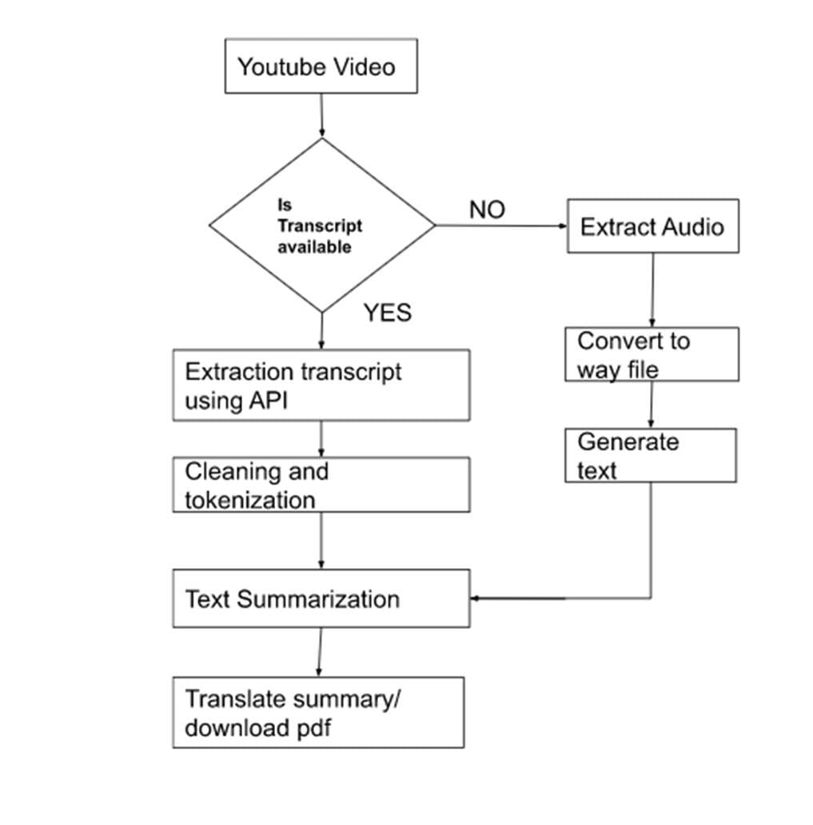Thisproject will provide us the chance to put cutting-edge NLP techniques for Abstractive and Extractive text summarization into practise while also implementing an intriguing notion that is ideal for intermediates, as well as a reviving side endeavor for experts**.**
    - **Steps for YouTube transcript Summarization: -**
    - **1) Using a Python API, find the transcripts and subtitles for a particular YouTube video ID.**
    - **2) If transcripts are available then perform text summarization on obtained transcripts using Hugging Face transformers.**
    - **3) If transcript is not available then download then extract audio from the video then using speech recognition convert audio into text.**
    - **4) Summarize the converted text.**
    - **5) We can translate summarized text in Hindi, English and Marathi by just selecting a language to translate text.**
    - **6) If required we can download the summary in pdf format**

## 5.PROJECT DESIGN

### Data Flow Diagram:

A Data Flow Diagram (DFD) is a traditional visual representation of the information flows within a system. A neat and clear DFD can depict the right amount of the system requirement graphically.

It can be manual, automated, or a combination of both.

### Level 0 DFD:

The Level-0 DFD, also called context diagram of the result management system is shown in Fig.5.1

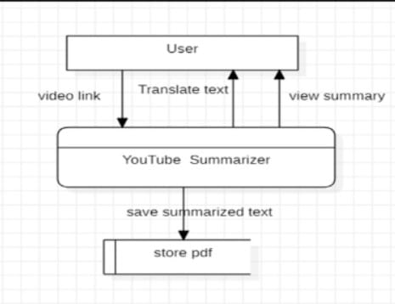

**Fig.5.1. Level 0 DFD**

* + 1. **Level 1 DFD:**

In 1-level DFD, a context diagram is decomposed into multiple bubbles/processes.

In this level, we highlight the main objectives of the system and breakdown the high-level process of 0-level DFD into subprocesses.

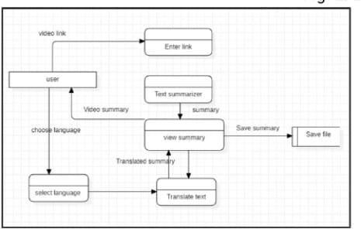

**Fig.5.2. Level 1 DFD**

## 6. SYSTEM REQUIREMENTS

### SOFTWARE REQUIREMENTS:

* + - Operating System: Windows
    - Front End: HTML, CSS, JavaScript
    - Back End: Flask Server
    - Web Browser
    - Tool Used: VS code

### HARDWARE REQUIREMENTS:

* + - Processor: Minimum dual core processor
    - Hard Disk: 512GB Minimum
    - RAM: 4GB Minimum
    - Mouse
    - Keyboard

## 

## 7. IMPLEMENTATION DTAILS

Implementation is the stage in the project where the theoretical design is turned into the working system and is giving confidence to the new system for the users

i.e. will work efficiently and effectively. It involves careful planning, investigation of the current system and its constraints on implementation, design of method to achieve the changeover, an evaluation, of change over methods.

A part from planning major task of preparing the implementation is education of users. The more complex system is implemented, the more involved will be the system analysis and design effort required just for implementation. An implementation coordinating committee based on policies of individual organization has been appointed.

The implementation process begins with preparing a plan for the implementation for the system. According to this plan, the activities are to be carried out, discussions may regarding the equipment phase. The most critical stage is in achieving a successful new system and in giving the users confidence that the new system will work and be effective.

### Admin/User Interface Design:

Admin/User Interface Design is concerned with the dialogue between a user and the computer. It is concerned with everything from starting the system of logging into the system to the eventually presentation of desired inputs and outputs. The overall flow of screens and messages is called a dialogue.

**The following steps are various guidelines for Admin/User Interface Design:**

* + - The system admin/user should always be aware of what to do next.
    - The screen should be formatted so that various types of information, instructions and messages always appear in the same general display area.
    - Message, instructions or information should be displayed long enough to allow the system admin/user to read them.
    - Use display attributes sparingly.
    - Default values for fields and answered to be entered by the admin/user should be specified.
    - A use should not be allowed to proceed without correcting an error.
    - The system admin/user should never get an operating system message or fatal error.

**7.1.1) INTERFACE DESIGN: (Important Screenshots of Front End)**

1. **Fig.7.1. HOME PAGE:**

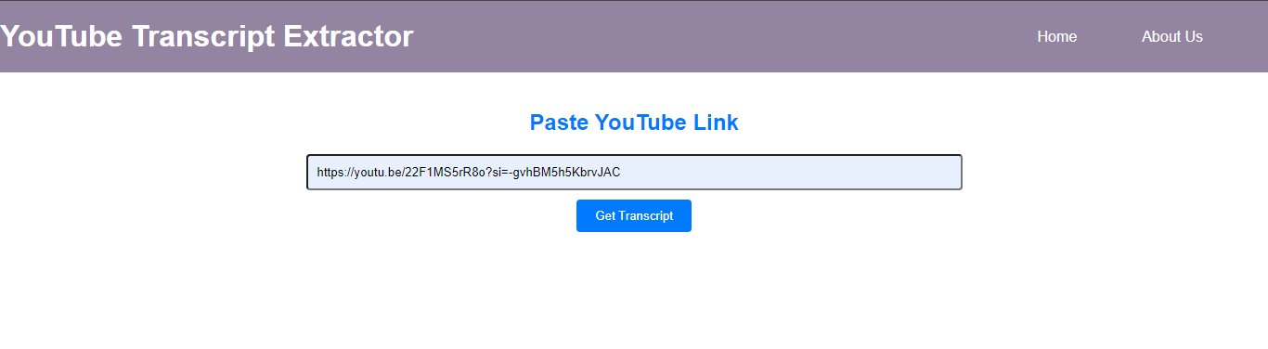

1. **Fig.7.2 About US Page:**

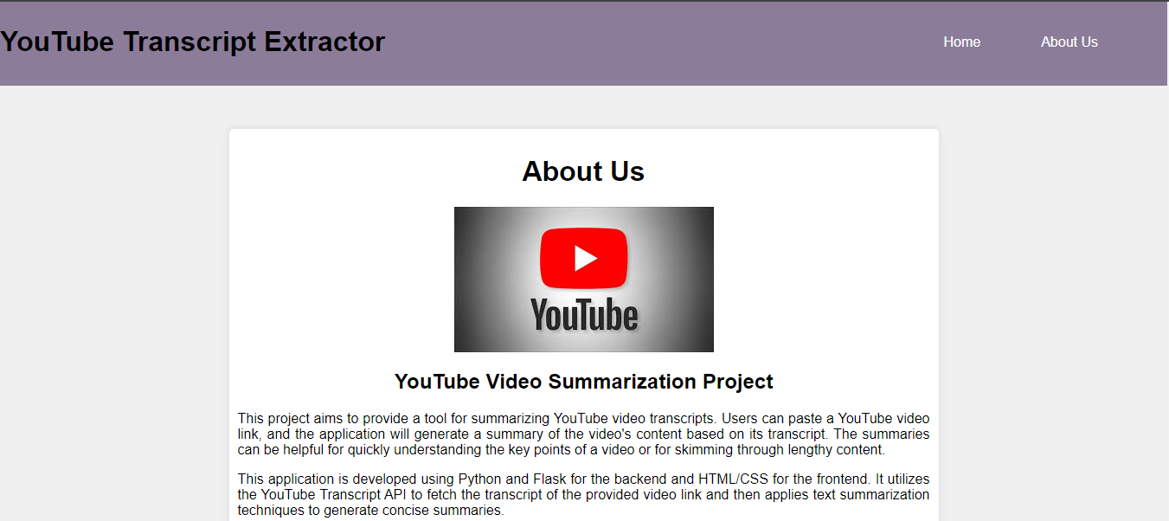

1. **Fig.7.3 . Result Page:**

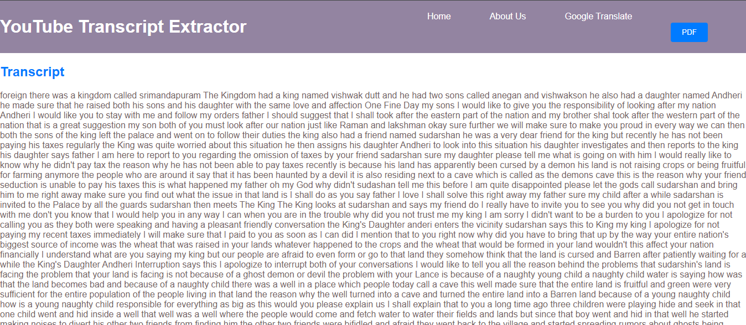

## 8. RESULT

We successfully developed a system capable of automatically

summarizing YouTube videos using advanced technologies such as

natural language processing.

• The system effectively distills key insights from lengthy videos into

concise summaries, enhancing user experience and facilitating better

information retrieval.

• User feedback and engagement indicate positive reception and

satisfaction with the generated summaries.

• The project highlights the potential of video summarization technology

to streamline content consumption and democratize access to

information in the digital age.

**Fig. Final Result**

**English Transcript**

## 

## Hindi Transcript

## 

## 9. CONCLUSION

Our project successfully demonstrated the power of Natural Language Processing (NLP) for summarizing YouTube videos. Our approach produced concise and informative summaries, improving the user experience. While our results were promising, there's room for improvement in fine-tuning models with domain-specific data and integrating multimedia features. Future work could explore multi-modal summarization and real-time applications.

## 10. REFERENCES

Here are some references for YouTube video summarization: -

1. Gygli, M., Grabner, H., Riemenschneider, H., & Van Gool, L. (2014). Creating summaries from user videos. In European Conference on Computer Vision (pp. 505-520). Springer, Cham.
2. Mahasseni, B., Lam, M., Todorovic, S., & Mori, G. (2017). Unsupervised video summarization with adversarial LSTM networks. In Proceedings of the IEEE Conference on Computer Vision and Pattern Recognition (pp. 1059-1068).
3. Potapov, D., Douze, M., Harchaoui, Z., & Schmid, C. (2014). Category-specific video summarization. In European Conference on Computer Vision (pp. 540-555). Springer, Cham.
4. Zhou, B., Khosla, A., Lapedriza, A., Oliva, A., & Torralba, A. (2018). Learning temporal coherence via self-supervision for GAN-based video generation. In Proceedings of the IEEE Conference on Computer Vision and Pattern Recognition (pp. 6833-6842).
5. Zhang, C., Wang, W., & Jiang, Y. G. (2016). Video summarization with long short-term memory. In European Conference on Computer Vision (pp. 766-782). Springer, Cham.